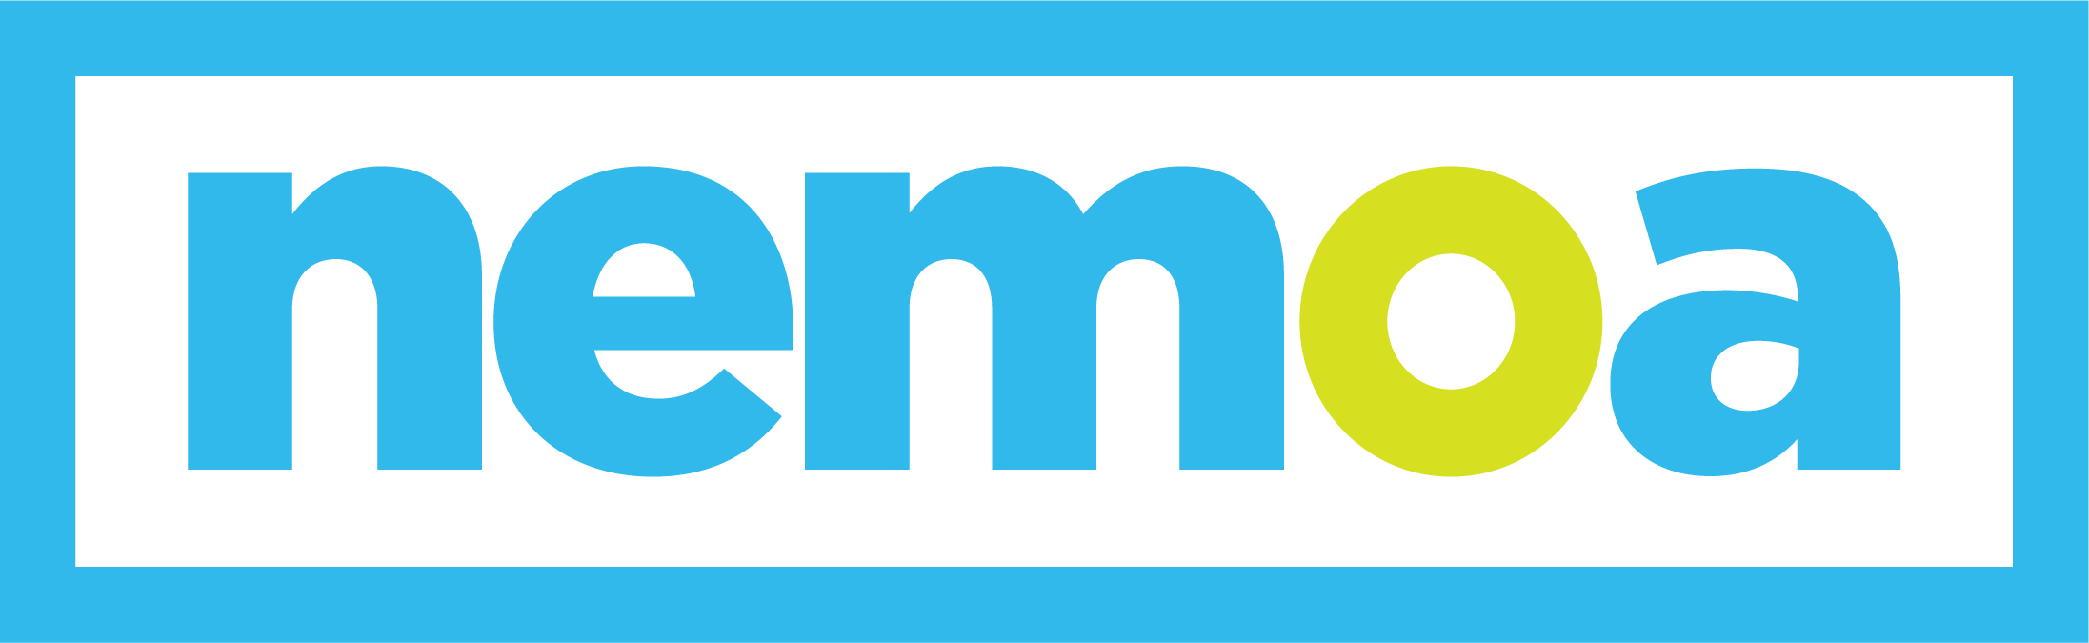
HARNESS THE POWER OF PRINT + DIGITAL MARKETING

Dear [your boss’s name]

The NEMOA Fall Summit is coming up from September 11–13, and I’d like your approval to attend. There is no better event for learning about multi-channel direct marketing and connecting with industry peers in a low-pressure environment. The NEMOA Summit offers unparalleled education and networking opportunities at an incredible value.

Here are the top five reasons I should attend this summit:
- I’ll have ample opportunities to network with merchants from companies who could use the innovative services we offer to positively impact their performance and revenue.
- I can connect directly with executives from companies large and small, learning about their challenges and offering solutions to overcome them.
- I’ll learn about current trends in multi-channel marketing, gaining insights into what we need to do to stay one step ahead for our clients.
- I will bring back tools to help us evolve our own strategy and enhance our entire organization.
- The summit is conveniently located in the heart of downtown Chicago, making travel a breeze and minimizing my out-of-office time.

I’ve already looked at the summit line-up, and I’m interested in connecting with attendees from [company name], [company name], and [company name.] The schedule offers networking breaks between almost every session, plus a happy hour networking event where I’ll have time to connect on a personal level. Plus, interactive discussions that will offer valuable takeaways that will help me understand the future of direct marketing.

By registering before August 9, I can save $250! That would bring my total cost to just [$XXX] to attend this amazing summit—an incredible value when you see other events charging thousands of dollars just for registration.

Itemized costs
- Summit registration [$XXX]
- Travel expenses [$XXX]
- Hotel [$XXX]
- Meals [$XXX] (meals during the event are included in the registration fee!)

I can put together a report for the team when I get back to share what I’ve learned about current best practices, new technologies, and what unfulfilled needs marketers have. I want to make sure we get the most out of this opportunity!

Thank you,
[your name]

P.S. If you think this summit sounds interesting, we can send more people and take advantage of the multi-person discount!

