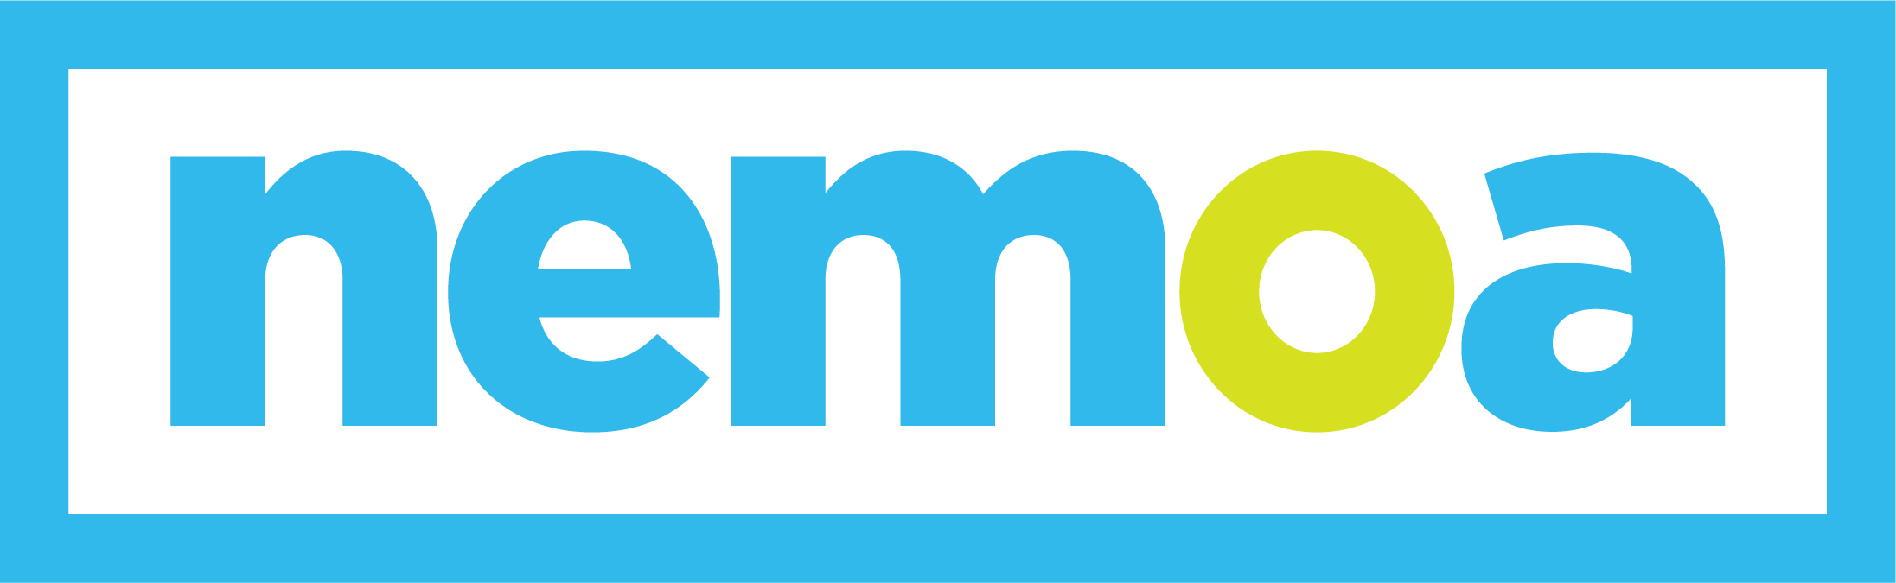
THE ONLY NATIONAL SUMMIT DEDICATED
TO CATALOGERS & ETAILERS

Dear [your boss’s name]

The NEMOA Fall Summit is coming up from September 12–14, and I’d like your approval to attend. There is no better event for learning about multi-channel direct marketing and connecting with industry peers in a non-selling environment. The NEMOA Summit offers unparalleled education and networking opportunities at an incredible value.

Here are the top five reasons I should attend this summit:
- I’ll learn from other marketers, gaining insights into how they’ve found success with their print, digital, and retail marketing programs.
- I can connect directly with executives from other brands, sharing challenges and finding solutions to overcome them.
- I’ll have ample opportunities to network with suppliers who offer the latest innovative services that could have a positive impact on our company’s performance and revenue.
- I will bring back tools to help us evolve our marketing strategy and enhance our entire organization.
- The summit is conveniently located just outside of Chicago, making travel a breeze and minimizing my out-of-office time.

I’ve already looked at the summit line-up, and the keynote speakers, like [speaker name from company name], sound engaging and inspiring. The breakout sessions and hands-on breakfast groups are perfectly tailored to areas I’d like to learn more about. Sessions like [session name from speaker name] will offer valuable takeaways that I can put to work right away.

By registering before August 17, I can save $200! That would bring my total cost to just [$XXX] to attend this amazing summit—an incredible value when you see other events charging thousands of dollars just for registration.

Itemized costs
- Summit registration [$XXX]
- Travel expenses [$XXX]
- Hotel [$XXX]
- Meals [$XXX] (meals during the event are included in the registration fee!)

I can put together a report for the team when I get back to share what I’ve learned about current best practices, new technologies, and what’s working for other marketers. I want to make sure we get the most out of this opportunity!

Thank you,
[your name]

P.S. If you think this summit sounds interesting, we can send an additional person for free!

